## Worksets

Worksets are a collection of similar building elements grouped into manageable sets to support team members working in a single model. Worksets need to be defined considering the project’s scope, size, and the number of team members. The project Revit Coordinators document the worksets in the project’s BIM Execution Plan. Team members may create additional worksets for the project but should always consult with their discipline Revit Coordinator to limit the number of worksets in a project. Worksets created by a user should be made Non-Editable to eliminate the need for constantly giving permission for other team members to edit objects. User-created worksets should be saved to the central file with the “User-created Worksets” box checked to ensure that the worksets will be available for other team members to use if needed.

When worksharing is enabled, Revit creates default worksets and assigns project elements to these worksets. Existing levels, grids and reference planes are moved automatically to the Shared Levels and Grids workset. Model elements are automatically assigned to a default workset called Workset1.

Create additional custom worksets to allocate elements into loadable slices of geometry, and make sure to reassign elements to the appropriate one. Avoid using Workset1 for any purpose, and do not rename it. It is generally understood that Workset1 is a system workset that should not be modified.

The purpose of worksets is to unload from the temporary memory segments of the model that are not critical for the immediate task of the modeler. Except in rare circumstances, Worksets are not to be used to control the permanent visibility of elements in views.

You can decide to display or not the contents of a workset in specific views. The workset dialog box provides a column of checkboxes that controls the display of workset in different views.

As the model progresses, always check that elements are placed in the corresponding workset. Every modeler is responsible for keeping elements in the appropriate workset. For maintenance and troubleshooting, create a dedicated 3D view for each workset.

Another method to review element workset assignment is to use the Worksharing Display Settings, which applies a temporary color override to visually distinguish workshared elements.

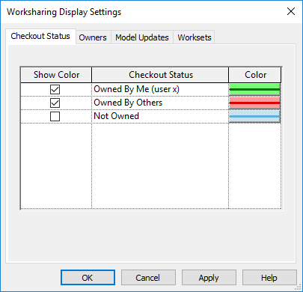

Figure 3.2‑1 Worksharing Display Settings

Revit offers several options when opening a Revit file with worksets (e.g. opening “all” worksets, “specify” user selected worksets, ‘last viewed’ to open worksets that were open during the last session, and ‘editable’ to open all worksets that are editable). Always use the “Specify” option to open only the worksets that you intend to work on at that time.